DigiSub

Banyan is Electroproject and sigmaStream true agnostic data agregation platform delivering AI based analytics, realtime Torque and Drag applications …

Drilling operations are conducted in a high-risk and high-cost environment. The recent COVID-19 pandemic is having a huge impact on the global energy demand. This crisis shows that companies must take advantage of the latest technological tools to become a data driven organization and gain competitive advantages. Foundation to success in the digital age is the ability and willingness to collect quality and comprehensive data to enable the use of the latest computational and analytical software tools. Adapting a strong high-frequency data and edge computing platform will provide operators with the resiliency and allow it to excel in a highly fluctuating business environment.

Use of advanced technologies such as Artificial Intelligence (AI) can help to realize significant efficiencies and reduce non-productive time (NPT) in all its operations. A well-appointed Real-Time Operating Center (RTOC) can facilitate drill-by-wire, reducing dependence on rig crew and leveraging the collective expertise and knowledge of the entire organization.

A key ingredient of this vision is high quality data.

Data frequency is a key factor for success
Rigs traditionally produce data once every 1-5 seconds. At best, the Electronic Data Recorder (EDR) published data at 1 Hz. Events such as drill-string stall, twist-off and certain aspects of stuck pipe develop and manifest themselves in a matter of seconds. If data is not collected at a high enough sampling rate, then operational events leading up to a drill-string stall or a twist-off, cannot be detected. The traditional 1 Hz data rate was primarily designed for human consumption and is not suitable for fast changing events for machine automation.

The DigiSub application within Banyan delivers 250 Hz high frequency surface torque and speed and offers a validated physics-based model that provides information about the dynamic sub-surface behavior of the drill-string, both along the drill-string and at the bit. Both Surface and downhole data are delivered synchornised and validated to the consumer.

There are very few systems available in the industry that can generate and manage sub-second data. The Banyan platform has been specially designed to have this functionality. Beside the DigiSub data Banyan easily collects data from all sources and all data frequencies at the rig for immediate consumption at the edge.

One of the problems in our industry is the diversity of data systems and providers, each with their distinctive protocol. Banyan is a universal translator and a protocol-agnostic data aggregation system that can be rolled out across a rig fleet, for a truly rig manufacturer and rig operating system neutral platform.

Banyan delivers context to DigiSub data
In addition to density, needed is the context for the data aggregated. Most of the aggregated data is surface information that is not correlated with downhole information. Downhole information is invaluable when combined with the surface data to interpret the behavior of the various rig components. For instance, severe drill-string oscillations exert tremendous stress on drill-string connections that could potentially cause a twist-off. Banyan allows for the computation and collection of downhole torque and speed data, at a 40-millisecond resolution, without the deployment of expensive downhole sensors.

- True real time, aggregated, synchronise and validated 250 Hz Surface Signals and 25 hz. downhole signals.Downhole signals calculated with validated models.
- Top Drive rotary speed
- Top Drive torque
- Applied drillpipe Torque
- Drillbit Speed
- Dynamic drill bit torque
- Drilling string speed on 150 points of the drillstring
- Dynamic Drillstring torque on 150 points of the drillstring
- Static drillstring torque for Torque & Drag analyses
- Realtime friction factor values.

Scope of work

The completed Banyan system will be as shown below:
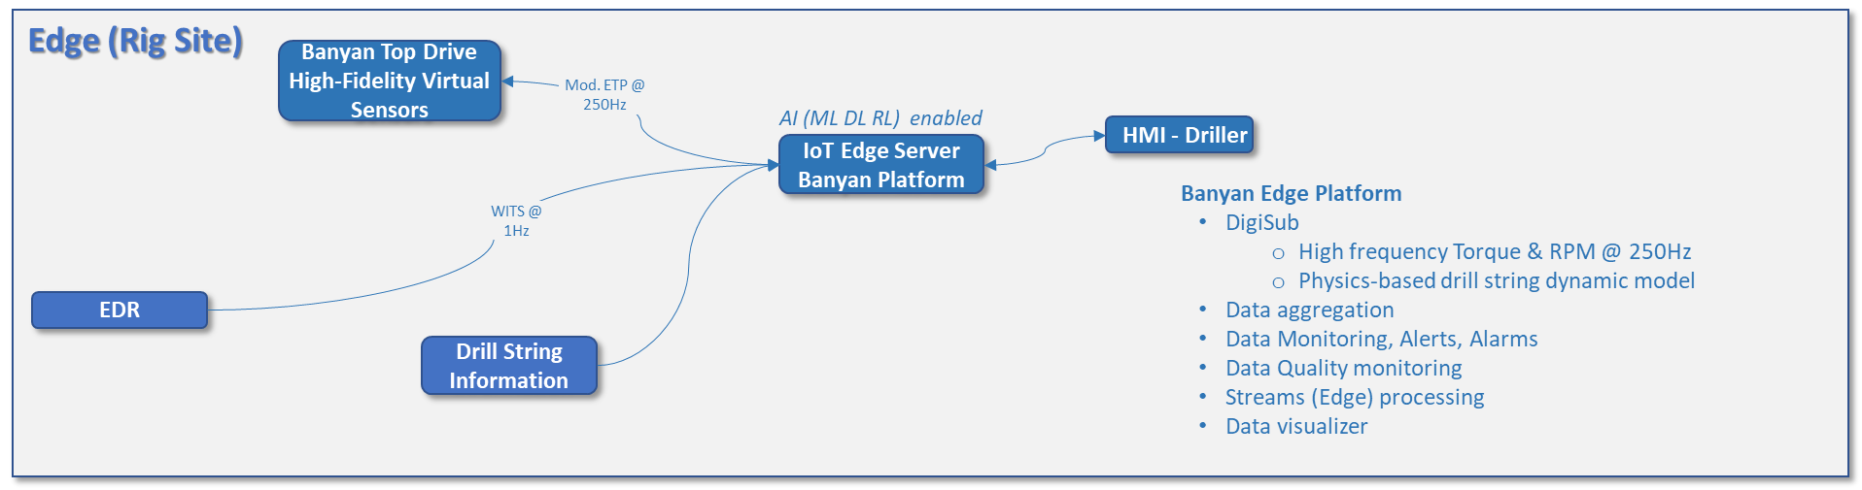

The field installation of the system will be as shown below:

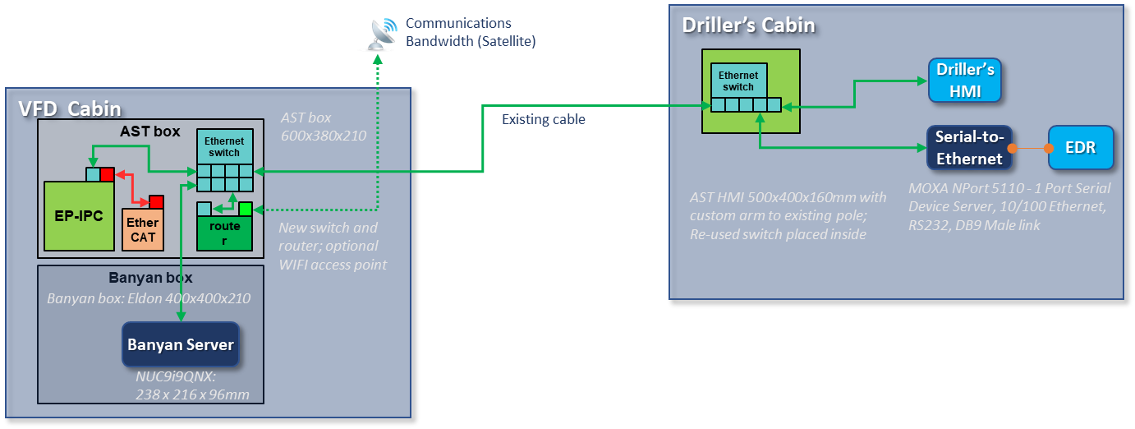

For the pilot, SigmaStream/Electroproject will install an Edge server to deploy Banyan applications. The Banyan Server will consist of two IPC’s. One the DigiSub-AST IPC, hosting the Banyan DigiSub connection with the top drive PLC and VFD and one hosting the Banyan platform itself.

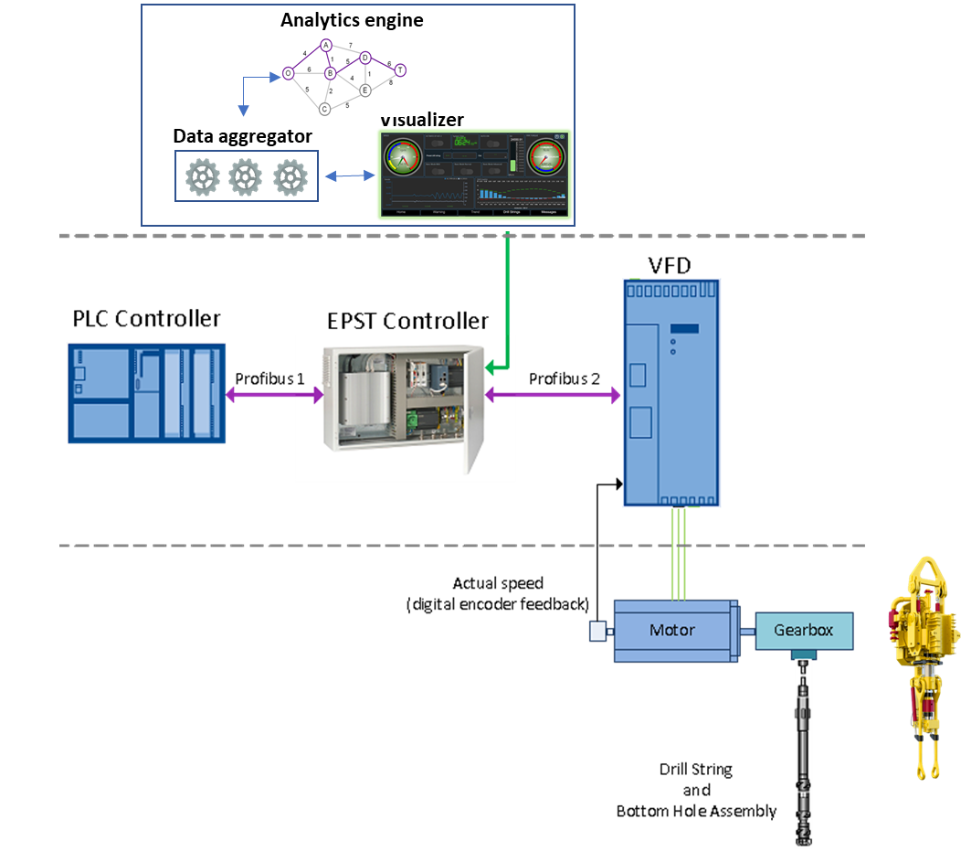

ANNEX 1: Additional Banyan benfits

AI based Predictive Maintenance (PdM) - Eagle
The ability to generate, collect and use unified (both high and low frequency) data at the edge allows for the institution of predictive maintenance practices. The use of AI to accomplish PdM is the next frontier in the Equipment Condition Monitoring (ECM) space. The first step towards a PdM strategy is the detection of anomalies. If anomalies are discrete or very short time-range events, it is not farfetched to postulate that certain precursors to a given anomaly can be predicted, giving engineers a chance to avert a catastrophic failure or an opportunity to schedule maintenance activities at an appropriate time.

Through Eagle, Banyan brings a manufacturer and equipment agnostic approach to the detection of anomalies using signals such as power consumption, vibration and sound emitted by the asset being monitored. Like any other Machine Learning (ML) model, Eagle needs to be trained and tested using data coming out of ADNOC rigs and this offers an opportunity for the two data science teams to collaborate.

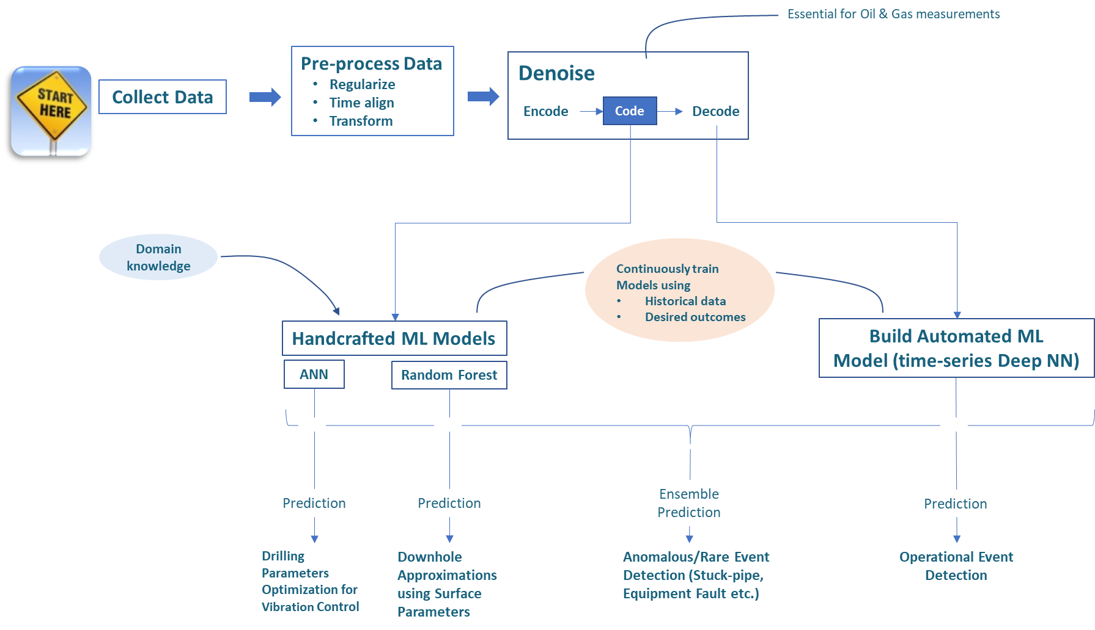

Examples of the value of high-frequency data: twist-off identification

The benefits of high frequency data are sometimes challenged but listed below are documented examples of the high value of this information.

The graph represents a stalling event followed by an unwinding drill-string. The actual speed is represented by the dark blue line dropping to 0 rpm and further down to “negative” speed meaning unwinding. How is this possible?

The unwinding event is caused by the PLC lowering the maximum torque setting from maximum to almost 0 within 3 seconds trying to cope with the stalling drill-string. By doing so, the residual torque in the drill-string forces the drill-string to speed up in the “negative” direction.

When we look at the time scale, we see that the PLC action takes place within 3 sec (from 4 to 7 in the time scale). The normal data aggregation frequency is 1 Hz at best, that drops to approx. 0.2 Hz when transferred to the RTOC. Within this timetable, it would have been impossible to recognize the root cause of this event with traditional low frequency EDR data.

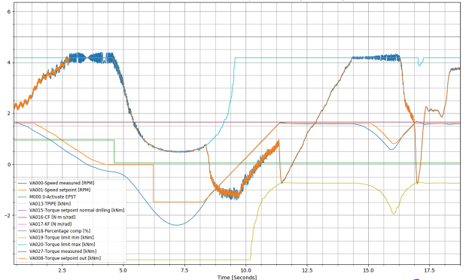

The message is even stronger when we combine the high frequency surface data with the calculated drill bit (BHA) speed (see graph above).

Additional to all the traditionally available data sources on a drilling rig, the Banyan DigiSub runs in real-time, a drill-string model fed with high frequency surface torque and speed information, delivering without additional surface or down hole sensors, at 250Hz frequency:

    - Top Drive rotary speed
    - Top Drive commanded torque
    - Drill string torque
    - Drill string and at bit rotational speed (deliver by the Downhole Observer)

In the example shown above the light blue line is drill bit speed. We see that ultimately the strong speed variations down hole lead to a twist off.

Before this happens we see that the drill bit is in heavy stick slip and we get a warning given by an almost stalling drill-string (red curve touching 0). The second time the drill-string stalls, it leads to a very high negative speed. The large difference between surface speed and drill bit speed puts the connection under stress ultimately leading to the twist off.

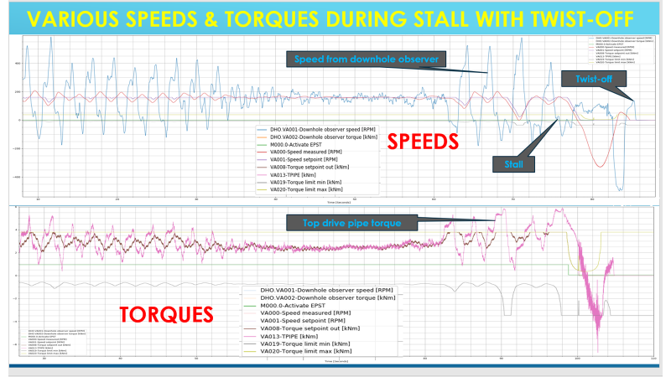

Examples of the value of high-frequency data: Connection analysis with high frequency data (250 Hz)
Connection data analyses is key to prevent twist offs and broken connections. The make-up and break-out torque patterns are used to quantify the quality of the connection. High frequency data offers visibility into how the connections are made up and broken out, and otherwise not visible with conventional 1 Hz data.

In the below example high Frequency data depict the various steps while making-up and braking out a connection. To do this the next data channels has been used:

- From the DigiSub (sample rate of 4ms / 250Hz):
- High resolution top drive pipe-torque in [kNm] (see Note-1 below)
- High resolution top drive rotation speed in [rpm]
- From rig data acquisition system (sample rate of 5s / 0.2Hz):
- Top drive torque in [kNm] (see Note-2 below)
- Top drive rotation speed in [rpm] (see Note-2 below)
- Hookload in [kN]
- Block position in [m]

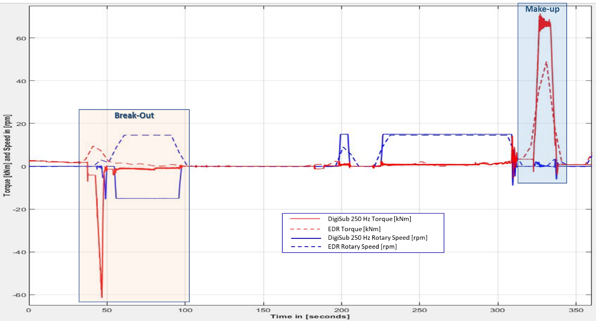

Note-1: The pipe-torque channel is a calculated torque at the interface between top drive and drill-string. This is done by removing from the realized top drive motor torque, the torque component necessary to accelerate and decelerate the mass moment of inertia. For this the momentary acceleration of the top drive is needed and can be calculated from the high-resolution speed channel.

Note-2: Most rig data acquisition systems do not recognize negative torque and speed. Therefore, if the physical values become negative, they will be recorded as flipped positive values. See the dashed lines in the figures. These signals are here only displayed to highlight the difference with the EPST high resolution signals

When zooming in, the added value of high frequency data is obvious when compared with traditional low frequency EDR data. The EDR data shows positive values for both torque and rotary speed when it should be negative values. In addition, the EDR shows severe aliasing and is far from the actual value which is accurately captured by the 250 Hz data. When the connections are measured and displayed at this high frequency level then we can clearly seed quality of the connection make-up where we can see the thread interaction when it engages and disengages.

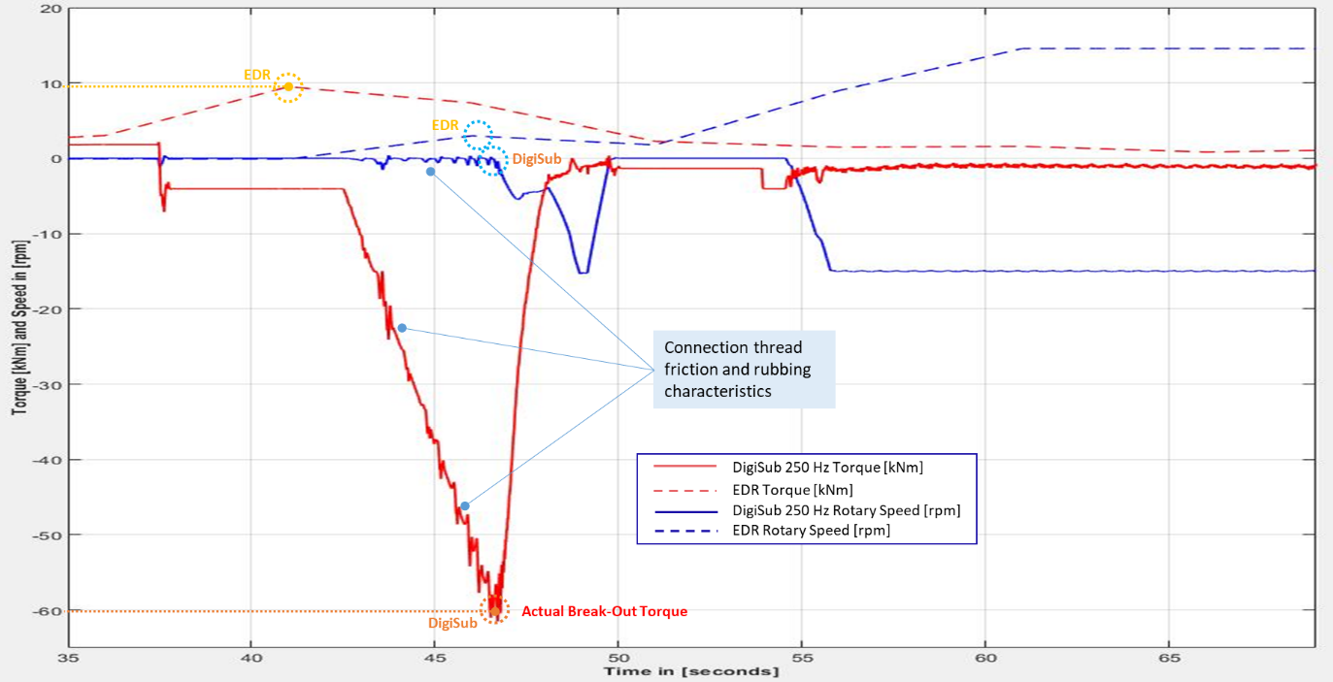

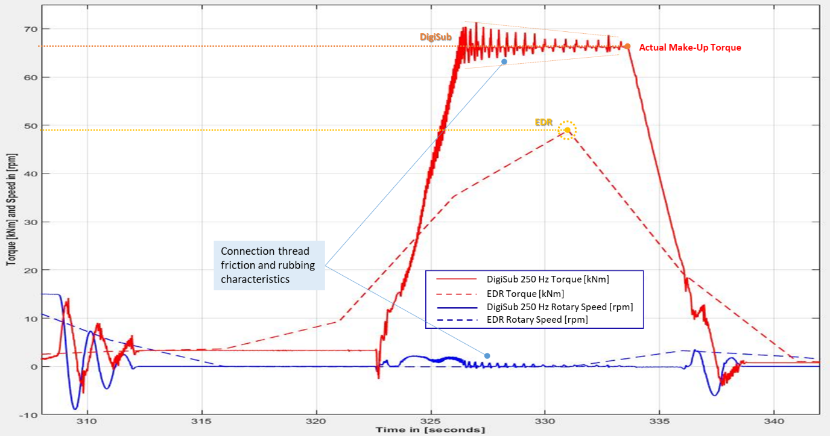

The showed in thread friction and rubbing phenomena are the signature for a healthy connection. AI and ML tools can use these patterns to recognize problems with the connection before the stand is used.

Examples of the value of high-frequency data: twist-off identification : Dynamic drill-string behavior visualization with Banyan DigiSub
The Banyan DigiSub is a powerful tool to visualize drill-string behavior without down hole sensors. The DigiSub application runs in real-time that utilizes high frequency speed and torque.

The DigiSub delivers the following high frequency (250 Hz) data without requiring the installation of additional physical sensors:
    - Top Drive speed
    - Top Drive commanded torque
    - Drill string torque
    - Drill string and bit speed (deliver by the Downhole Observer)

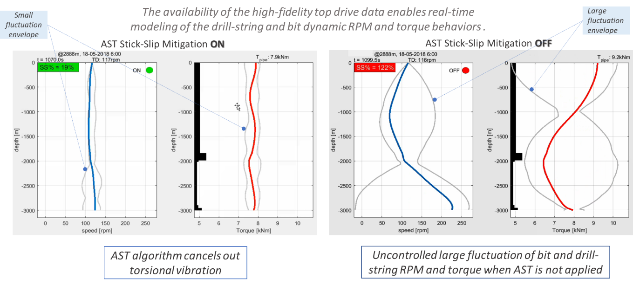

The DigiSub can also be used for offline research purposes.

