BANYAN

Analytics and AI-applications to improve well drilling execution

Drilling operations are conducted in a high-risk and high-cost environment. The recent COVID-19 pandemic is having a huge impact on the global energy demand. This crisis shows that companies must take advantage of the latest technological tools to become a data driven organization and gain competitive advantages. Foundation to success in the digital age is the ability and willingness to collect quality and comprehensive data to enable the use of the latest computational and analytical software tools. Adapting a strong high-frequency data and analytics platform will provide operators with the resiliency and allow it to excel in a highly fluctuating business environment.

Use of advanced technologies such as Artificial Intelligence (AI) can help to realize significant efficiencies and reduce non-productive time (NPT) in all operations. A well-appointed Real-Time Operating Center (RTOC) can facilitate drill-by-wire, reducing dependence on rig crew and leveraging the collective expertise and knowledge of the entire organization.

A key ingredient of this vision is high quality data. The Banyan platform is especially designed to deliver data and insights necessary for operational excellence. Analytics is performed both at the rig site as well as the corporate environment to deliver timely information to key and relevant decision makers.

In addition to a number of benefits the Banyan platform comes bundled with, here's a list of Banyan specific unique values:
- a one stop-shop for the acquisition and aggregation of data produced via various protocols, of various formats, frequencies (1 Hz, 5 Hz, 20 Hz, 100 Hz, 250 Hz, etc.) and clocks
- the ability to perform edge analytics and not only generate recommendations to the rig personnel, in situ, but also produce a number of calculated channels of data useful for on-rig visualization and reporting needs
- the ability to securely and efficiently transmit as much or as little of the raw and computed channel data, at any desired cadence (1 Hz, 5 Hz, 20 Hz, 100 Hz, 250 Hz, etc.)
- the capability to train Eagle, the Banyan Predictive Maintenance (PdM) Machine Learning (ML) algorithm, using the high frequency top drive data produced by the Electroproject AST already deployed at these rigs

Data frequency is a key factor for success
Rigs traditionally produce data once every 3-5 seconds. At best, the Electronic Data Recorder (EDR) published data at 1 Hz. Events such as drill-string stall, twist-off and certain aspects of stuck pipe develop and manifest themselves in a matter of seconds. If data is not collected at a high enough sampling rate, then operational events leading up to a drill-string stall or a twist-off, cannot be detected. The traditional 1 Hz data rate was primarily designed for human consumption and is not suitable for fast changing events.

There are very few systems available in the industry that can generate and manage sub-second data. The Banyan platform is a state-of-the-art system that provides a unique capability to easily collect data from all sources and all data frequencies for immediate consumption at the edge. Additionally, the platform offers a validated physics-based model that provides information about the dynamic sub-surface behavior of the drill-string, both along the drill-string and at the bit.

One of the problems in our industry is the diversity of data systems and providers, each with their distinctive protocol. Banyan is a universal translator and a protocol-agnostic data aggregation system that can be rolled out across a rig fleet, for a truly rig manufacturer and rig operating system neutral platform.

Context is needed to interpret the data
In addition to density, needed is the context for the data aggregated. Most of the aggregated data is surface information that is not correlated with downhole information. Downhole information is invaluable when combined with the surface data to interpret the behavior of the various rig components. For instance, severe drill-string oscillations exert tremendous stress on drill-string connections that could potentially cause a twist-off. Banyan allows for the computation and collection of downhole torque and speed data, at a 4-millisecond resolution, without the deployment of expensive downhole sensors.

AI based Predictive Maintenance (PdM) The ability to generate, collect and use unified (both high and low frequency) data at the edge allows for the institution of predictive maintenance practices. The use of AI to accomplish PdM is the next frontier in the Equipment Condition Monitoring (ECM) space. The first step towards a PdM strategy is the detection of anomalies. If anomalies are discrete or very short time-range events, it is not farfetched to postulate that certain precursors to a given anomaly can be predicted, giving engineers a chance to avert a catastrophic failure or an opportunity to schedule maintenance activities at an appropriate time.

Banyan PdM brings a manufacturer and equipment agnostic approach to the detection of anomalies using signals such as power consumption, vibration and sound emitted by the asset being monitored. Like any other Machine Learning (ML) model, Eagle needs to be trained and tested using data coming out of ADNOC rigs and this offers an opportunity for the two data science teams to collaborate.

Invisible Lost Time (ILT)
There has been an increase in focus on ILT in many service companies and operators in recent years.

The Banyan platform can automate the application of the lessons learnt for an optimal operational performance. The suite of existing operational events and Key Performance Indicators (KPIs), available in the platform, will allow both the operator and the contractor to automate the ILT reduction initiative and gain immediate benefits as data is collected and processed, in-situ, as well as in the corporate environment. Time spent that was formerly “invisible” will now be “visible” because of the ability to collect diverse data and apply advanced analytics and AI techniques. The resulting improvements can be delivered to all levels of the drilling organization, from field personnel to engineering and management.

Key capabilities
To create a robust and cost-effective solution, the following set of capabilities is needed:
- Ability to synchronize data from the EDR, rig Operating System (OS) and other available high frequency data sources - all unified into a single data stream that is available for immediate processing, using the latest conventional and AI algorithms
- Ability to generate high frequency data from relevant sources like the Top Drive (TD), without having to install additional physical sensors
- Ability to simulate drill-string and bit behavior downhole using only surface data
- Ability to run approximations outlined above in real-time using high frequency data (>100 Hz)
- Ability to run real-time models and data driven computations to deliver Torque and Drag (T&D) analysis, in real-time
- Ability to perform edge analytics

- Provide high-frequency Banyan DigiSub data:
  - real-time drill-string speed and torque information at 250 Hz frequency
  - drill-string torque and speed behavior along the drill-string and at the bit

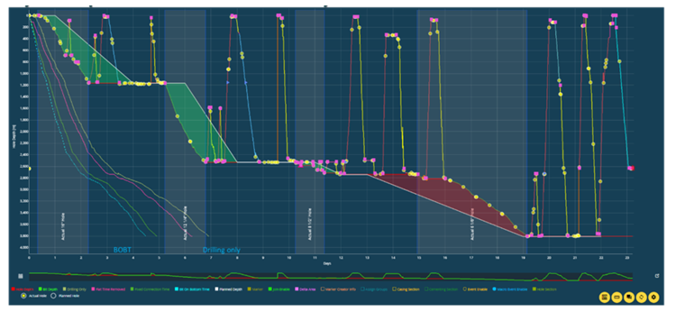

Well performance analysis.

Implementation of Banyan

The field installation in highlines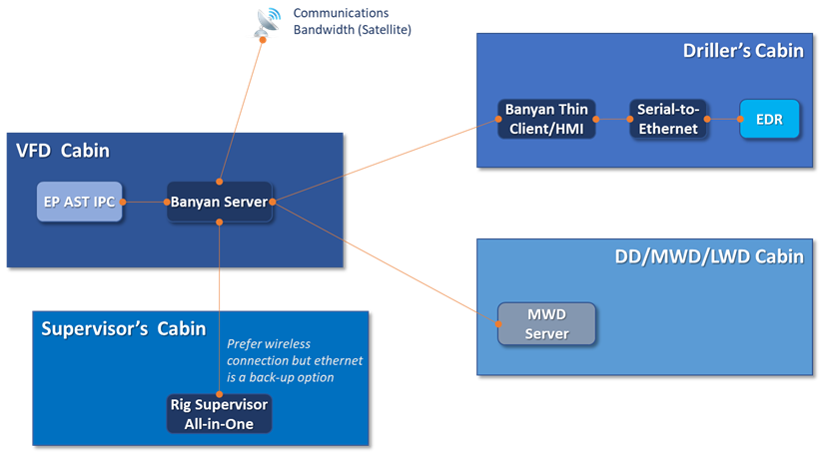

Examples of the value of high-frequency data: twist-off identification

The benefits of high frequency data are sometimes challenged but listed below are documented examples of the high value of this information.

The graph represents a stalling event followed by an unwinding drill-string. The actual speed is represented by the dark blue line dropping to 0 rpm and further down to “negative” speed meaning unwinding. How is this possible?

The unwinding event is caused by the PLC lowering the maximum torque setting from maximum to almost 0 within 3 seconds trying to cope with the stalling drill-string. By doing so, the residual torque in the drill-string forces the drill-string to speed up in the “negative” direction.

When we look at the time scale, we see that the PLC action takes place within 3 sec (from 4 to 7 in the time scale). The normal data aggregation frequency is 1 Hz at best, that drops to approx. 0.2 Hz when transferred to the RTOC. Within this timetable, it would have been impossible to recognize the root cause of this event with traditional low frequency EDR data.

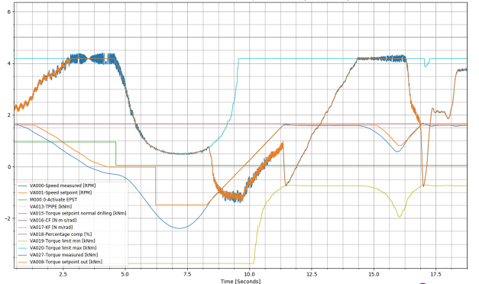

The message is even stronger when we combine the high frequency surface data with the calculated drill bit (BHA) speed (see graph above).

Additional to all the traditionally available data sources on a drilling rig, the Banyan DigiSub runs in real-time, a drill-string model fed with high frequency surface torque and speed information, delivering without additional surface or down hole sensors, at 250Hz frequency:

    - Top Drive rotary speed
    - Top Drive commanded torque
    - Drill string torque
    - Drill string and at bit rotational speed (deliver by the Downhole Observer)

In the example shown above the light blue line is drill bit speed. We see that ultimately the strong speed variations down hole lead to a twist off.

Before this happens we see that the drill bit is in heavy stick slip and we get a warning given by an almost stalling drill-string (red curve touching 0). The second time the drill-string stalls, it leads to a very high negative speed. The large difference between surface speed and drill bit speed puts the connection under stress ultimately leading to the twist off.

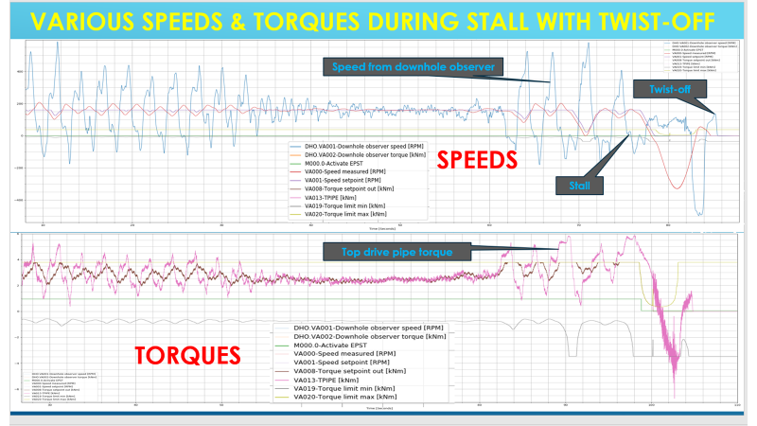

Examples of the value of high-frequency data: Connection analysis with high frequency data (250 Hz)

Connection data analyses is key to prevent twist offs and broken connections. The make-up and break-out torque patterns are used to quantify the quality of the connection. High frequency data offers visibility into how the connections are made up and broken out, and otherwise not visible with conventional 1 Hz data.

In the below example high Frequency data depict the various steps while making-up and braking out a connection. To do this the next data channels has been used:

- From the DigiSub (sample rate of 4ms / 250Hz):
- High resolution top drive pipe-torque in [kNm] (see Note-1 below)
- High resolution top drive rotation speed in [rpm]
- From rig data acquisition system (sample rate of 5s / 0.2Hz):
- Top drive torque in [kNm] (see Note-2 below)
- Top drive rotation speed in [rpm] (see Note-2 below)
- Hookload in [kN]
- Block position in [m]

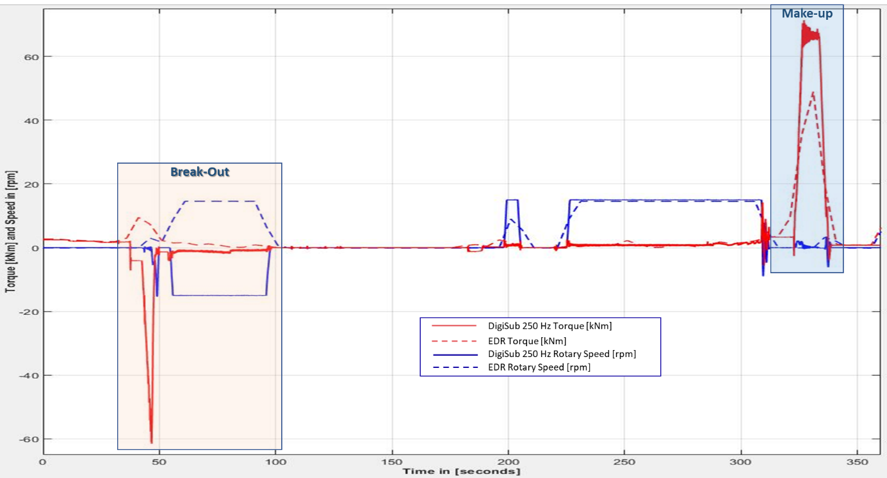

Note-1: The pipe-torque channel is a calculated torque at the interface between top drive and drill-string. This is done by removing from the realized top drive motor torque, the torque component necessary to accelerate and decelerate the mass moment of inertia. For this the momentary acceleration of the top drive is needed and can be calculated from the high-resolution speed channel.

Note-2: Most rig data acquisition systems do not recognize negative torque and speed. Therefore, if the physical values become negative, they will be recorded as flipped positive values. See the dashed lines in the figures. These signals are here only displayed to highlight the difference with the EPST high resolution signals

When zooming in, the added value of high frequency data is obvious when compared with traditional low frequency EDR data. The EDR data shows positive values for both torque and rotary speed when it should be negative values. In addition, the EDR shows severe aliasing and is far from the actual value which is accurately captured by the 250 Hz data. When the connections are measured and displayed at this high frequency level then we can clearly seed quality of the connection make-up where we can see the thread interaction when it engages and disengages.

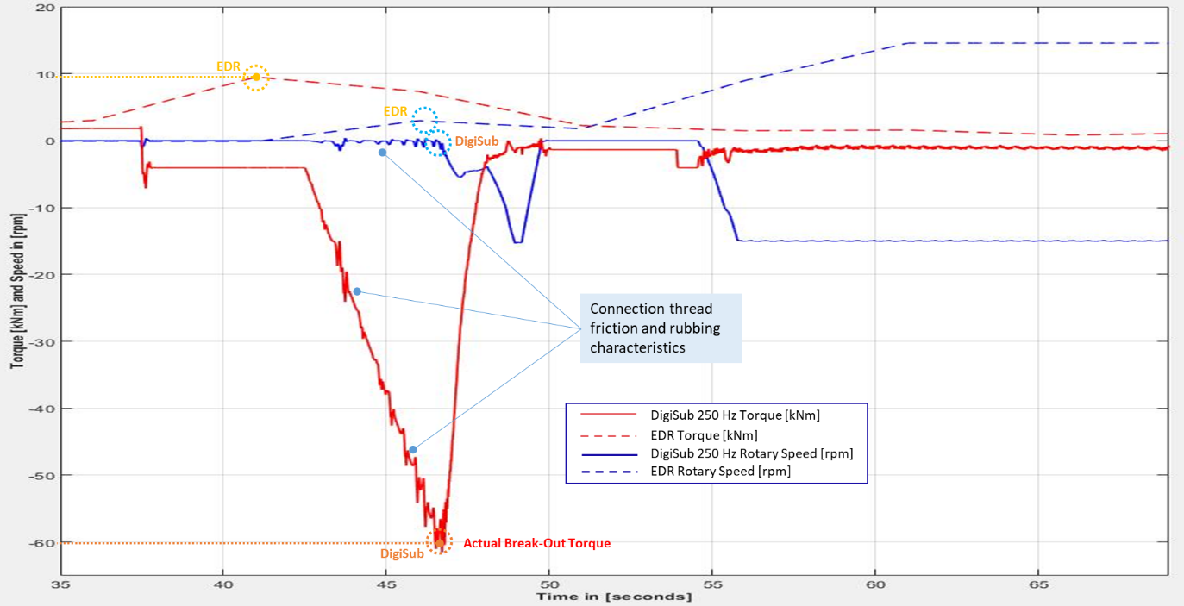

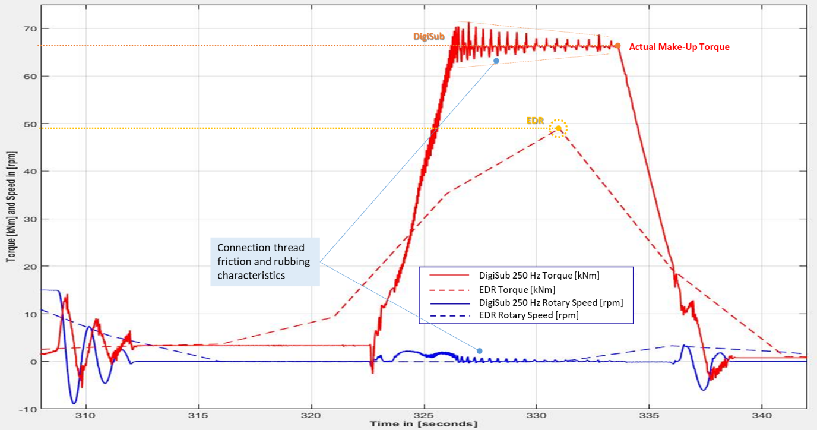

The showed in thread friction and rubbing phenomena are the signature for a healthy connection. AI and ML tools can use these patterns to recognize problems with the connection before the stand is used.

Examples of the value of high-frequency data: Dynamic drill-string behavior visualization with Banyan DigiSub.

The Banyan DigiSub is a powerful tool to visualize drill-string behavior without down hole sensors. The DigiSub application runs in real-time that utilizes high frequency speed and torque.

The DigiSub delivers the following high frequency (250 Hz) data without requiring the installation of additional physical sensors:
    - Top Drive speed
    - Top Drive commanded torque
    - Drill string torque
    - Drill string and bit speed (deliver by the Downhole Observer)

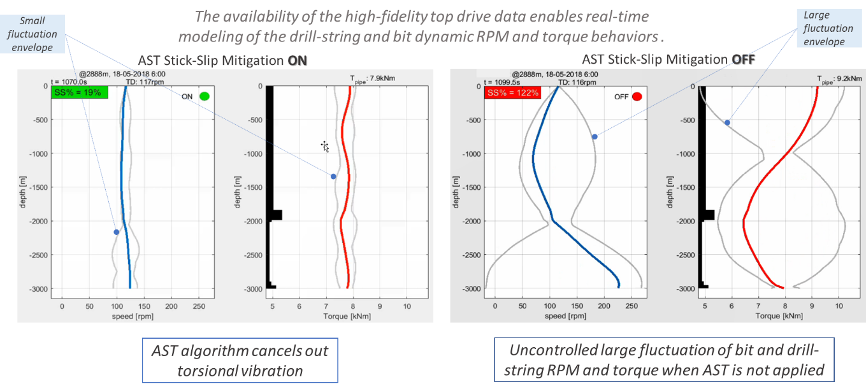

The DigiSub can also be used for offline research purposes.

Examples of analytics, KPIs, and engineering visualizer

Engineering Visualizer – Days vs Depth analytics and collaboration
The Banyan system automatically generates Operational Events and KPIs. Banyan transforms the typical Days vs Depth plot into a collaborative tool that merges time-based data with expert opinion (i.e. drillers, rig manager, rig supervisor, engineers, managers, etc.). Multiple users can input markers to log their analyses simultaneously. Some other features are listed below:
- Calculate drilling only time
- Bit-On-Bottom-Time (BOBT)
- Theoretical time with elimination of all stand drilling NPT
- Theoretical fixed connection time

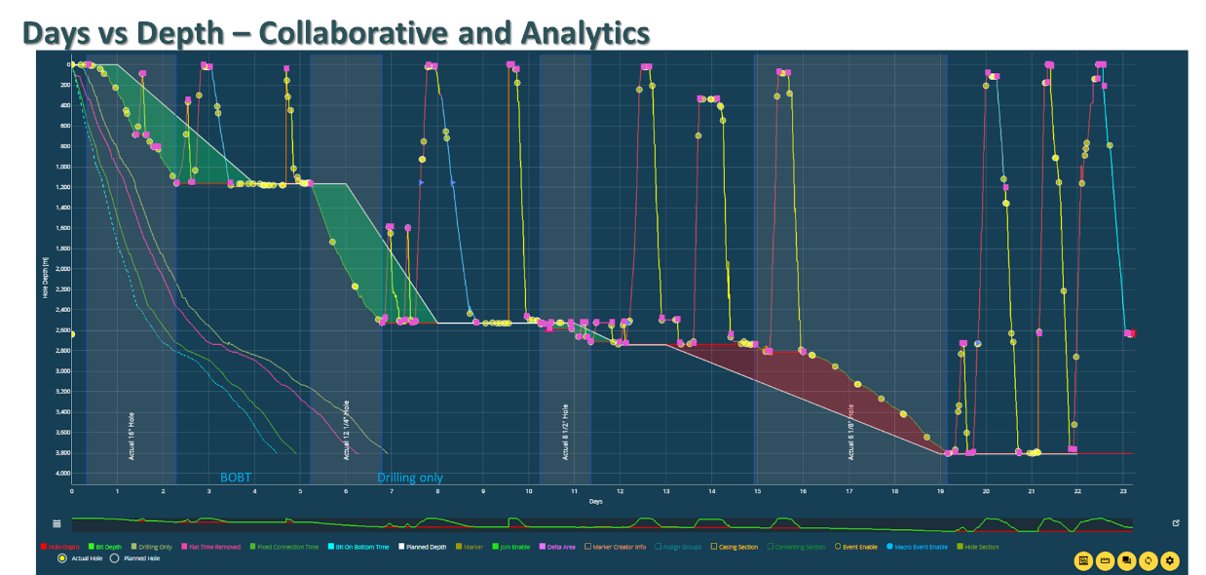

KPI – Automated Well Summary Report
The Banyan platform can automatically generate a comprehensive wells operational summary according to hole sections and inclusive of:
- Drilling
- Tripping, casing/liner/tubing running – quantifying both open and cased hole
- BHA make-up and laydown time
- Cementing operation
- Hole conditioning
- FIT/LOT test

Banyan can automatically generate the following comprehensive well report, something that would be quite difficult and labor intensive to assemble.
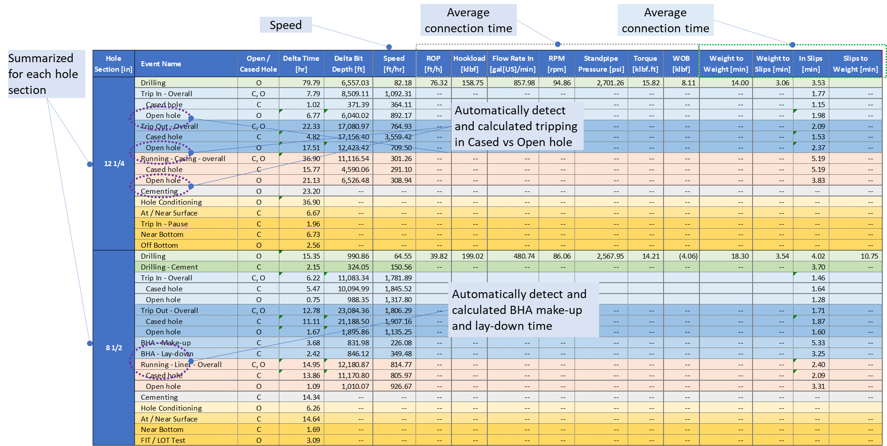

KPI – 24 Hours Analysis
Time breakdown of an operational day with individual columns representing each hour of the day. The hourly bar charts are color coded to account of operational activities (or events). Additionally, the KPI allows for easy comparison of performance of crews.
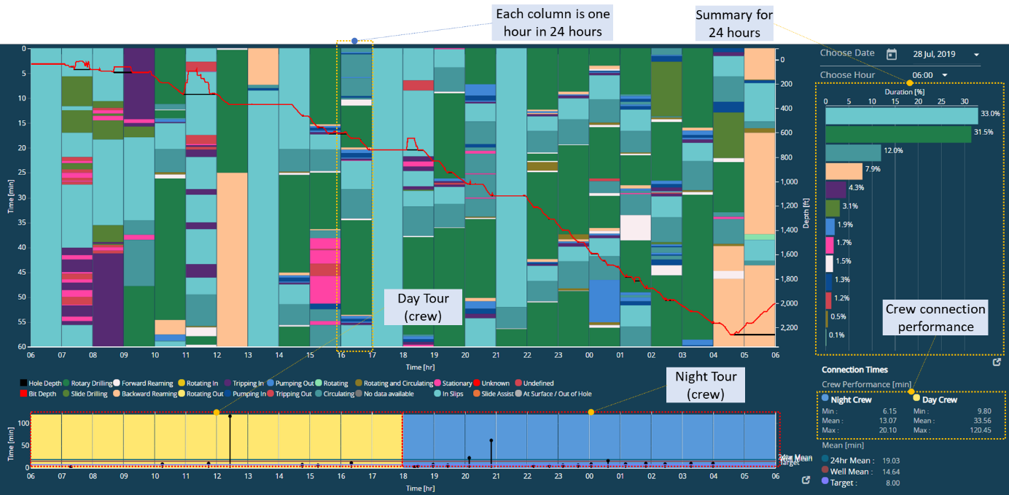

KPI – Connection Analysis
Banyan’s automatic quantification of drilling, tripping, and casing/liner/tubing connections. If given sufficient data quality, the algorithm can identify if the operation underway is drilling (with pre-slips, in-slips, and post-slips) or connection, which only consist of in-slips activity.

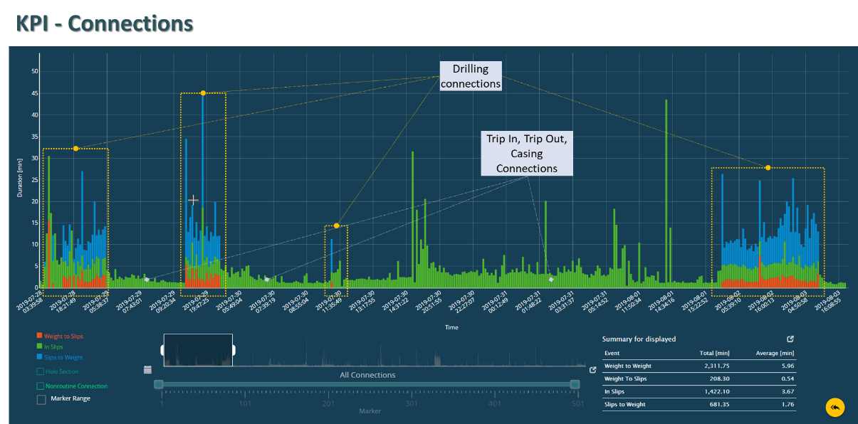

Annex 6.E: KPI – Drilling Connections
Graphically displays all drilling connections for the well while accounting for weight-to-slips, in-slips and slips-to-weight time.

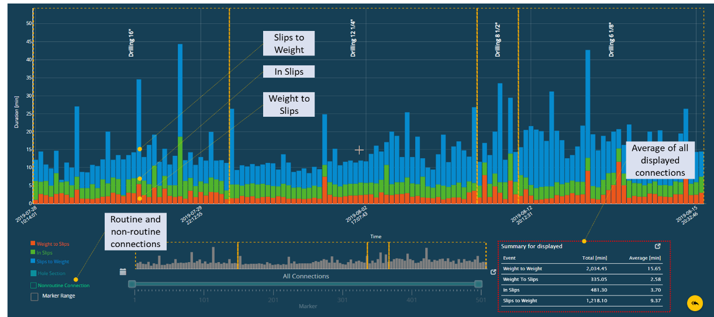

Annex 6.F: KPI – Advanced Connection Analysis
The Advanced Connection KPI is an interactive display that allow the user to easily quantify and understand connection trends. The Banyan platform not only calculates the typical weight-to-weight, weight-to-slips, in-slips and slips to weight time, but provides further break down of the connection time. The identification of events enables easy identification of both systematic (habitual) vs non-routine operations practices. For example, if a crew or driller typically backward and forward reams a full stand before making a connection, then this habitual behavior can be identified and quantified, and decisions made as to whether to keep these practices.

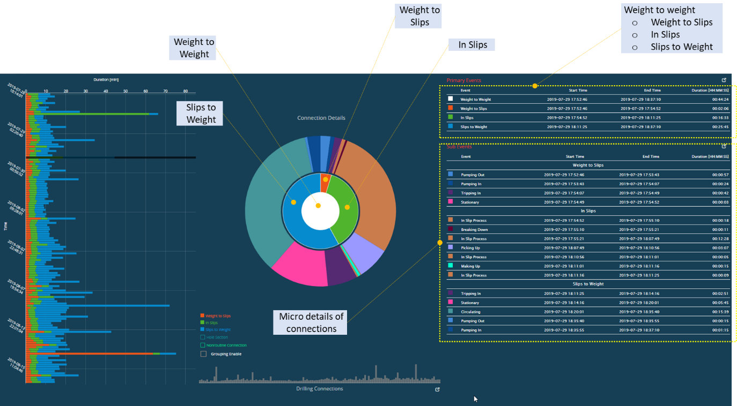

Annex 6.G: KPI – ROP Analysis
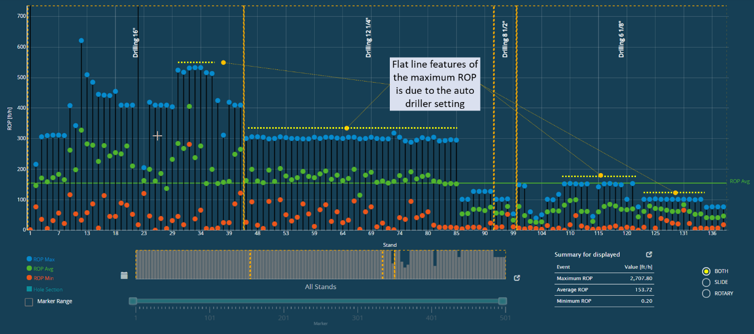

KPI - Speed Analysis
Banyan independently generates its own speed calculations for:
- Drilling
- Tripping In
- Tripping Out
- Running casing
- Running Liner and tubing

The speed calculation is for both cases where connection time is included and excluded. Speed with connection time allows for tracking of general tripping efficiency and on the other hand, speed without connection is important for swab and surge considerations.
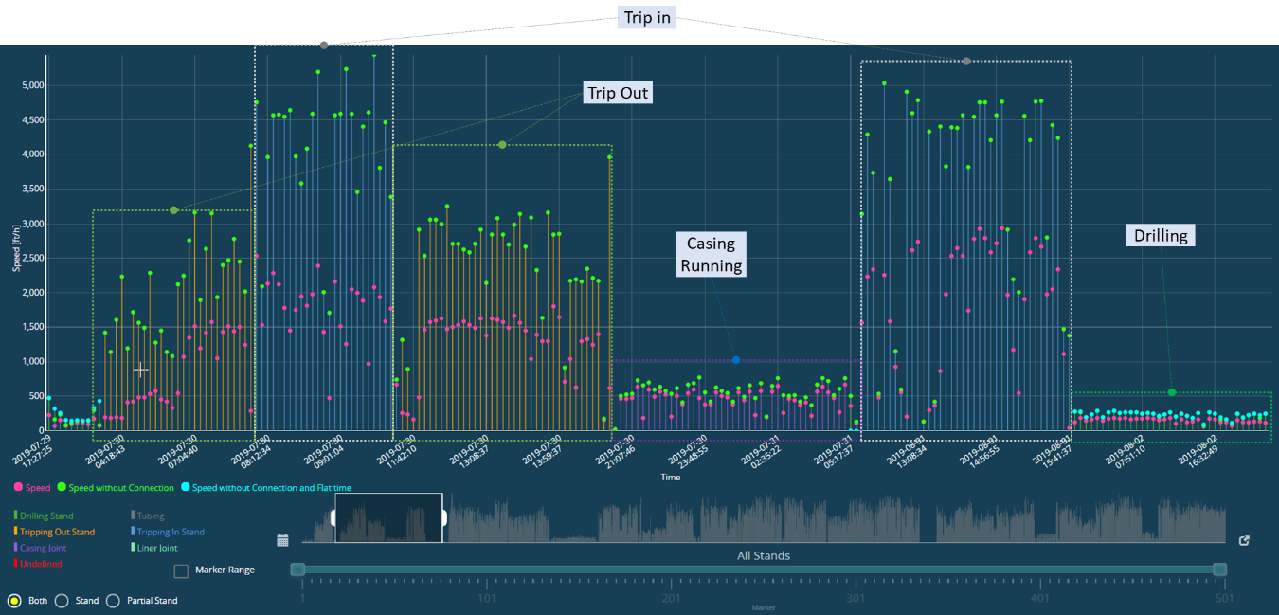

KPI Operational Events
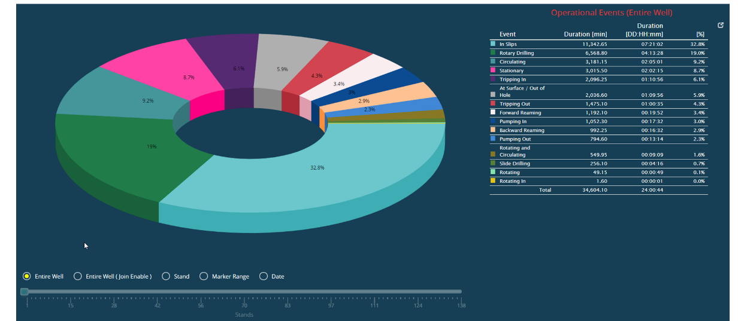

Real-time Torque and drag calculations.

The Real Time T&D application delivers calculation of Torque and Drag (effective tension) distribution along the drill-string while drilling. The module combines a real-time physics-based model of the drill-string with actual data driven values derived via AI algorithms. This combination real-time physics model and data driven analytics results is unique capability

Some applications are:
- Prediction of Torque and hookload requirements for a drilling section
- Real-time back calculation of actual friction factors
- Real-time calibration of effective friction trends to monitor (and warn) drilling and hole issues (e.g. differential sticking, stalling trend, key-seats, cuttings build up)
- Assist in the quantification of vibration damping along the drill-string to improve stick-slip mitigation simulation/prediction

Real-time T&D output include:
- Torque and Drag distribution along drill-string (see example 1)
- Side force distribution and orientation along drill-string
- Rig Torque and Hookload trends over bit depth (see example 2)
- Friction factor sensitivity (varying friction values)

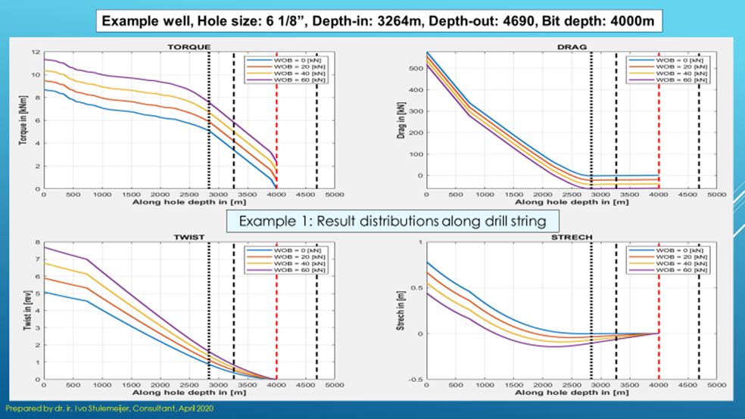

The system also automatically calculates WOB and WOB Set Point, independent of the Driller’s WOB setpoint. The manual WOB setpoint has a potential of introducing human errors and bad practices. The automated method is a computational AI-based algorithm that can consistently captures and calculate true Surface WOB values.

